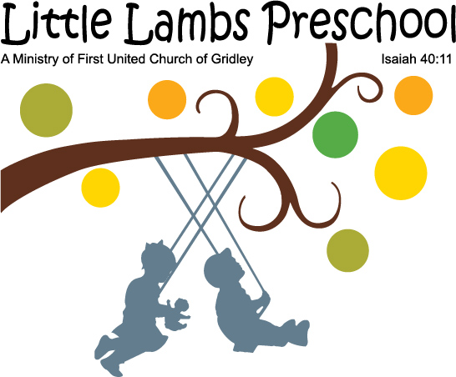
"Spring is coming
Spring is coming
Hear the birds
Hear the birds
They are busy digging
They are busy digging
big fat worms
big fat worms!!"
Have you heard your child singing this little song? It is a favorite Springtime rhyme in our class, and the children especially love singing the "big, fat worms" part. I am positive the children will also enjoy learning about earthworms as they observe them in our classroom later this month. Thank you to Darci Harland who will be visiting us on April 18th and 19th to share some earthworm activities she has written for preschoolers.

Welcome Spring/Earthworms
We will be doing activities about the letters S, U, W, and X, learning about earthworms, hearing Bible stories from the book of Acts, and more.
Reminders:
*Monthly tuition is due the first class day of the month. Please remember to make checks payable to First United Church - Little Lambs.
Enrollment is open for the 2013/14 school year. Students previously enrolled have priority for placement. Please let me know if your child will be returning for the 2013/14 school year. If you know parents who are interested in enrolling their child, have them contact me at (309) 310-7186.

Activities in March

April 2013
Newsletter

